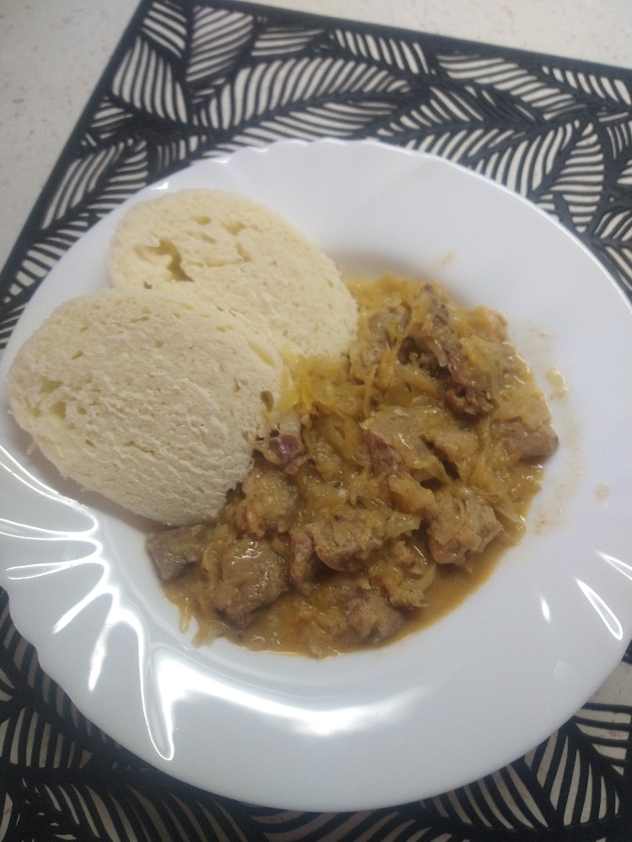
-Pork shoulder
cabbage goulash

-Onion
-Caraway
-Ground pepper
-Oil
-Salt
-Ground pepper
-Sauerkraut
-all-purpose flour
-cooking cream
In a pressure cooker, let the finely chopped onion become translucent in the oil. Add diced meat and cumin.
Fry the meat, season it with salt and pepper. Add red ground paprika and fry for a short time.
Then immediatelly add about 4 dl of water and close the pot. Simmer it under pressure for about 20 minutes.
Put cabbage in an ordinary pot, add about 3 dl of water and let it boil for about 20 minutes.
Before cabbage is cooked add 3 table spoons of plain flour mixed in about 2.5 dl of water and add it into the pot mixing.
Add the meat and all the juices from the pressure cooker to the cooked cabbage and bring to the boil again
Gradually stir in the curse (you don’t have to use all o fit) and simmer slowly forabout 20 minutes.
Finnaly, add half a cup of cream and if necessary, season the goulash again.

